**Service Level List:** The Service Level List tab allows you to load service level information on any CNH order type for use in sending orders to CNH. **NOTE:** You must first make sure you have loaded the Order Types list in order to use this feature.

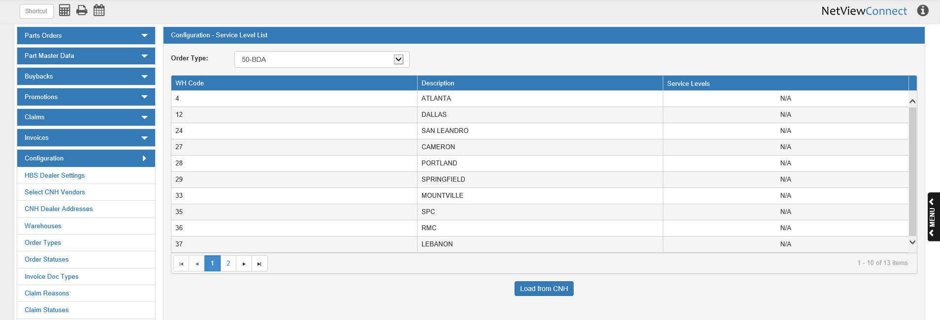

**Load from CNH:** You will only need to click this button to load a service level list the first time you open CNH Connect (CSPS). Afterwards, the list will automatically reload every time you change the order type whose service levels you want available, or every 30 days if you have not changed order types by that time. You may also click the button at any point to receive the most updated list for the order type currently selected.

**Order Type:** Select the order type whose service levels you want to have available from this drop-down menu. When you first access this tab, the default type will be “50-BDA,” but once you change the order type it should always default to your selection until you select a different order type. **NOTE:** You may only load the Service Level List for one type at a time. If you need to have the service levels available for a different type when sending an order, you will have to come to this tab and load that type’s list before proceeding.

**Column Definitions:**

WH Code: This column holds the code for the warehouse that does or does not have service levels available for the order type.

* If no warehouse has service levels for that order type, then all available warehouses will display.
* If at least one warehouse has service levels, then only the warehouse(s) with service levels will display.

Description: This column holds the warehouse description, typically indicating its location.

Service Levels: This column shows whether or not the warehouse has service levels. If none of the warehouses have service levels for the selected order type, every entry in this column will read, “N/A.”

However, if at least one warehouse has service levels available for the order type, then this column will hold a **View** button, as seen in the image below.

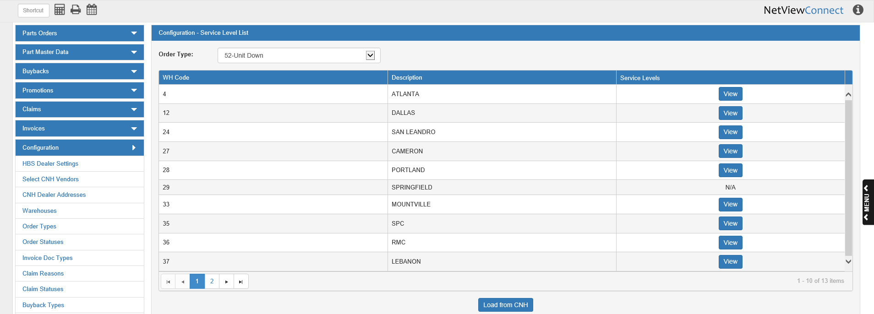

Clicking the button will open the service level list for the warehouse in the following window:

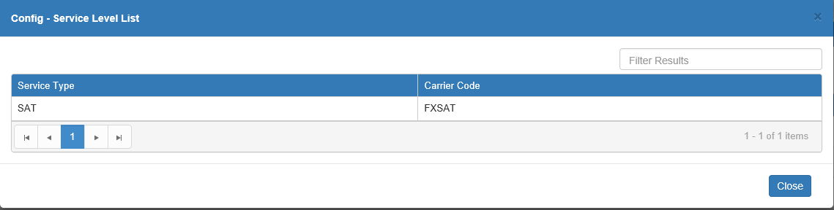

It shows the list of available service types and their accompanying carrier codes that you now have access to when making orders of the chosen type.